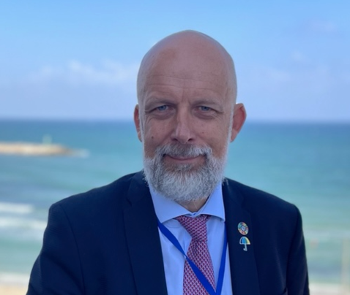**Toomas Palu** has had a long professional career in progressively senior roles in global health development. As the manager of the World Bank’s health portfolio in the East Asia and Pacific region and an adviser on global health coordination with the global health organizations in Geneva, Toomas was a member of the global leadership team of the Global Practice for Health, Nutrition and Population in the World Bank. He has worked with 31 countries in Europe, Asia and Pacific, and Africa. Currently, Toomas is advising the WHO team in Ukraine, Estonia’s Ministry of Social Welfare, and lecturing in global health at the Tartu University and Tallinn Technical University in Estonia. Toomas’ expertise lies in the health system strengthening, health financing and service delivery reforms. Toomas has a *cum laude* MD degree from the Tartu University and Master of Public Administration degree from the Harvard University in the US. He has also studied social policy and medical anthropology at the Oxford University and health economics at the University of York in the UK.